CCPA

California School Dashboard

Local Indicators

Fall 2017
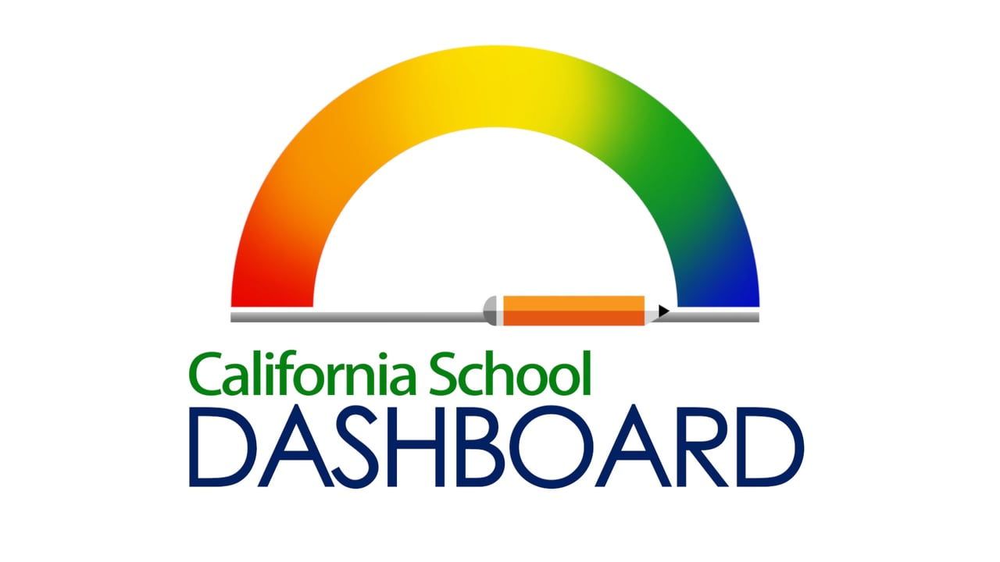

Priority 1

Priority 1

Appropriately Assigned Teachers, Access to Curriculum-Aligned Instructional Materials, and Safe, Clean and Functional School Facilities
(The local performance indicator for appropriately assigned teachers, access to curriculum-aligned instructional materials, and safe, clean and functional school facilities).

Standard: Local educational agency annually measures its progress in meeting the Williams settlement requirements at 100% at all of its school sites, as applicable, and promptly addresses any complaints or other deficiencies identified throughout the academic year, as applicable; and provides information annually on progress meeting this standard to its local governing board and to stakeholders and the public through the evaluation rubrics.

Criteria: Met
Narrative:
- All teachers are appropriately assigned within the College and Career Preparatory Academy(CCPA).
- All students have access to their own copies of standards-aligned instructional materials for use at school and home.
- There were no Williams complaints submitted during the 2016-17 school year. All College and Career Preparatory Academy facilities report on the School Accountability Report card had an overall rating of good for facility conditions.

Priority 2

Self-Reflection Tool for Implementation of State Academic Standards
(The local performance indicator for the implementation of state academic standards)
Standard: Local educational agency annually measures its progress implementing state academic standards and reports the results to its local governing board at a regularly scheduled meeting of the local governing board and to stakeholders and the public through the evaluation rubrics.

Criteria: Met

1. Rate the LEA’s progress in providing professional learning for teaching to the recently adopted academic standards and/or curriculum frameworks identified below. Rating Scale (lowest to highest): 1 – Exploration and Research Phase; 2 – Beginning Development; 3 – Initial Implementation; 4 – Full Implementation; 5 – Full Implementation and Sustainability

 | 1 | 2 | 3 | 4 | 5
ELA – Common Core State Standards for ELA |  |  |  | x
ELD (Aligned to ELA Standards) |  |  |  | x
Mathematics – Common Core State Standards for Mathematics |  |  | x
Next Generation Science Standards |  |  | x
History – Social Science |  |  |  | x

2. Rate the LEA’s progress in making instructional materials that are aligned to the recently adopted academic standards and/or curriculum frameworks identified below available in all classrooms where the subject is taught. Rating Scale (lowest to highest): 1 – Exploration and Research Phase; 2 – Beginning Development; 3 – Initial Implementation; 4 – Full Implementation; 5 – Full Implementation and Sustainability

 | 1 | 2 | 3 | 4 | 5
ELA – Common Core State Standards for ELA |  |  |  | x
ELD (Aligned to ELA Standards) |  |  |  | x
Mathematics – Common Core State Standards for Mathematics |  |  | x
Next Generation Science Standards |  |  | x
History – Social Science |  |  |  | x

3. Rate the LEA’s progress in implementing policies or programs to support staff in identifying areas where they can improve in delivering instruction aligned to the recently adopted academic standards and/or curriculum frameworks identified below (e.g., collaborative time, focused classroom walkthroughs, teacher pairing). Rating Scale (lowest to highest): 1 – Exploration and Research Phase; 2 – Beginning Development; 3 – Initial Implementation; 4 – Full Implementation; 5 – Full Implementation and Sustainability

 | 1 | 2 | 3 | 4 | 5
ELA – Common Core State Standards for ELA |  |  |  | x
ELD (Aligned to ELA Standards) |  |  |  | x
Mathematics – Common Core State Standards for Mathematics |  |  |  | x
Next Generation Science Standards |  |  | x
History – Social Science |  |  |  | x

Other Adopted Academic Standards
4. Rate the LEA’s progress implementing each of the following academic standards adopted by the state board for all students. Rating Scale (lowest to highest): 1 – Exploration and Research Phase; 2 – Beginning Development; 3 – Initial Implementation; 4 – Full Implementation; 5 – Full Implementation and Sustainability

 | 1 | 2 | 3 | 4 | 5
Career Technical Education |  |  | x
Health Education Content Standards |  |  |  | x
Physical Education Model Content Standards |  |  |  | x
Visual and Performing Arts |  |  | x
World Language |  |  |  | x

Support for Teachers and Administrators
5. During the 2015-16 school year (including Summer 2015), rate the LEA’s success at engaging in the following activities with teachers and school administrators? Rating Scale (lowest to highest): 1 – Exploration and Research Phase; 2 – Beginning Development; 3 – Initial Implementation; 4 – Full Implementation; 5 – Full Implementation and Sustainability

 | 1 | 2 | 3 | 4 | 5
Identifying the professional learning needs of groups of teachers or staff as a whole |  |  |  | x
Identifying the professional learning needs of individual teachers |  |  | x
Providing support for teachers on the standards they have not yet mastered |  |  | x

Priority 3

Self-Reflection Tool for Parent Engagement
(The local performance indicator for parent engagement)
Standard: Local educational agency annually measures its progress in: (1) seeking input from parents in decision making; and (2) promoting parental participation in programs, and reports the results to its local governing board at a regularly scheduled Narrative:
- CCPA has adopted standards-aligned instructional materials for English Language Arts, Social Science and Math.
- CCPA is in the initial stages of the math curriculum implementation with training and usage of curriculum beginning in January 2018.
- CCPA teachers have attended training on the Social Science framework, September 2017.
- CCPA teachers have received training in implementing the new social science curriculum, October 2017.
- Six teachers on special assignment support teachers in the implementation of the new curriculum and develop lessons to assist teachers to promote the implementation and use of the curriculum.
- Ongoing support for the teachers in the use of the new curriculum is offered weekly during small group support time.
- Science materials are being reviewed for alignment with the Next Generation Science Standards.

Criteria: Met

Summarize:
1. Key findings from the survey related to seeking input from parents/guardians in school and district decision making:
There were 498 surveys completed by parents. The parents were mailed copies of the survey, it was distributed electronically and some parents were called to increase the participation. There were also a parent information nights and parent advisory meetings scheduled throughout the year to increase parent engagement and awareness of the LCAP process. The survey targeted 3 main areas: School Climate, Parent Involvement, and the Use of Technology. These were target areas in the LCAP.
- Eighty-two percent of ACCESS parents and eighty-nine percent of Special Schools parents responded to being informed and receiving help from the school when needed.
- Eight-seven percent of ACCESS parents and ninety-seven percent of Special School parents responded that school is safe place for their child.
- In the survey question regarding making educational progress and meeting the learning needs of their child, eighty-seven percent of ACCESS parents and Special School parents agreed this was taking place for their child.
- At least ninety percent of ACCESS and Special School parents/guardians use a technological device at home and at least eighty-nine percent of parents surveyed have internet access at home.
- Eighty seven percent of parents stated approval of the LCAP goals and the actions and services that support the goals.

Key comments from the survey:
- Good communication with the school and teachers is strong.
- Add more educational and training opportunities for parents.
- Transportation to a school is a challenge based upon the location of the school sites.
- Look at opening a parent portal to have access to student academic information.

2. The key findings from the survey related to promoting parental participation:
- Eighty-seven percent of parents have met with their child’s teacher
- Seven-four percent of ACCESS parents and seven-six percent of Special Schools parents responded yes to being invited to participate in events and trainings
- Eighty percent of ACCESS parents are aware of opportunities to be involved at school
- Ninety percent of Special Schools parents responded that they receive help from school staff when requested

3. Why the local educational agency chose the selected survey and whether the findings relate to the goals established for other Local Control Funding Formula priorities in the Local Control Accountability Plan.

The parent survey has been utilized for the past 4 years. A similar survey is used with students and staff to gauge satisfaction among key stakeholders. The survey has been modified each year to gain additional information based upon comments received. The questions asked in the survey are tied to the goals, actions and services written the LCAP. Survey questions addressed the following:
- School safety
- Student progress
- School climate
- School communication
- Parent involvement
- LCAP goals
- College and career readiness
- Parent participation in school events
- Use of technology
- Internet access
- Child’s use of technology
- Child’s use of technology at school
- Classroom expectations and support
- Student behavior

Priority 6

School Climate
(The local performance indicator for school climate)
Standard: Local educational agency administers a local climate survey at least every other year that provides a valid measure of perceptions of school safety and connectedness, such as the California Healthy Kids Survey, to students in at least one grade within the grade span(s) that the local educational agency serves (e.g., K-5, 6-8, 9-12), and reports the results to its local governing board at a regularly scheduled meeting of the local governing board and to stakeholders and the public through the evaluation rubrics.

Criteria: Met

Narrative:
ACCESS administers the California Healthy Kids Survey to students in grades 5, 8 and 9-12. These results are communicated to school administrators and this data is used to evaluate student support services at the school sites. This analysis has resulted in increased clinical services for students, The School Accountability Report Card as well as the outcome measures in LCAP report pupil suspension data, dropout data, and graduation rate. In the past 3 years the suspension and dropout data have decreased and the graduation rate has increased.
All of this information when used with other relevant data such as CAASPP assessment results, CELDT data, pre and post assessment data from Scantron Performance Series will assist leadership in planning and developing measureable goals for continuous improvement.

Priority 9

Coordination of Services for Expelled Students - COE Only
(The local performance indicator for the coordination of services for expelled students. This form is for county offices of education only)
Standard: County office of education annually measures its progress in coordinating instruction as required by Education Code Section 48926 and reports the results to its local governing board at a regularly scheduled meeting of the local governing board and to stakeholders and the public through the evaluation rubrics.

Criteria: Met
Narrative:
The Orange County Department of Education coordinates the Tri-Annual Countywide Expulsion Plan. This plan is approved by the County Board of Education before submittal to the California Department of Education. Directors of Child Welfare Attendance and ACCESS administrators meet 5 times a year to address student attendance issues, discipline concerns, and legal issues impacting the area of student services. The Expulsion Plan is reviewed annually and is currently being updated for the submission to the County Board of Education by June 2018.

Coordination of Services for Expelled Students – COE Only (Priority 9)
Assess the degree of implementation of the progress in coordinating instruction for expelled students in your county?
Rating Scale (lowest to highest): 1 – Exploration and Research Phase; 2 – Beginning Development; 3 – Initial Implementation; 4 – Full Implementation; 5 – Full Implementation and Sustainability

Priority 9
- Assessing status of triennial plan for providing educational services to all expelled students in the county, including:  - Review of required outcome data | 1 | 2 | 3 | 4 | 5  X
- Identifying existing educational alternatives for expelled pupils, gaps in educational services to expelled pupils, and strategies for filling those service gaps. | 1 | 2 | 3 | 4  X | 5
- Identifying alternative placements for pupils who are expelled and placed in district community day school programs, but who fail to meet the terms and conditions of their rehabilitation plan or who pose a danger to other district pupils. | 1 | 2 | 3 | 4  X | 5
- Coordinating on development and implementation of triennial plan with all LEAs within the county. | 1 | 2 | 3 | 4 | 5  X
- Establishing ongoing collaboration and policy development for transparent referral process for LEAs within the county to the county office of education or other program options, including dissemination to all LEAs within the county a menu of available continuum of services for expelled students. | 1 | 2 | 3 | 4 | 5  X
- Developing memorandum of understanding regarding the coordination of partial credit policies between district of residence and county office of education. | 1 | 2 | 3 | 4  X | 5

Priority 10

Coordination of Services for Foster Youth – COE Only
(The local performance indicator for the coordination of services for foster youth. This form is for county offices of education only)
Standard: County office of education annually measures its progress in coordinating services for foster youth and reports the results to its local governing board at a regularly scheduled meeting of the local governing board and to stakeholders and the public through the evaluation rubrics web-based system (California School Dashboard).

Criteria: Met

Narrative:
The Orange County Department of education meets with the school district foster youth liaisons 5 times each year to coordinate services, review foster youth data, and to strategize effective procedures to minimize foster youth school transfers. The manager of Foster Youth Services is a member of the Blue Ribbon Commission meetings that focuses on countywide outcomes for foster youth. The manager is also a liaison between juvenile court and the district to assist in resolving foster youth placements and issues. This has resulted in issues being resolved in a timely manner.

Coordination of Services for Foster Youth – COE Only (Priority 10)
Assess the degree of implementation of coordinated service program components for foster youth in your county?
Rating Scale (lowest to highest): 1 – Exploration and Research Phase; 2 – Beginning Development; 3 – Initial Implementation; 4 – Full Implementation; 5 – Full Implementation and Sustainability
Priority 10 | 1 | 2 | 3 | 4 | 5
- Establishing ongoing collaboration and supporting policy development, including establishing formalized information sharing agreements with child welfare, probation, Local Education Agency (LEAs), the courts, and other organizations to support determining the proper educational placement of foster youth (e.g., school of origin versus current residence, comprehensive versus alternative school, and regular versus special education). | 1 | 2 | 3 | 4 | 5  X
- Building capacity with LEA, probation, child welfare, and other organizations for purposes of implementing school-based support infrastructure for foster youth intended to improve educational outcomes (e.g., provide regular professional development with the Foster Youth Liaisons to facilitate adequate transportation services for foster youth). | 1 | 2 | 3 | 4 | 5  X
- Providing information and assistance to LEAs regarding the educational needs of foster youth in order to improve educational outcomes. | 1 | 2 | 3 | 4 | 5  X
- Providing direct educational services for foster youth in LEA or county-operated programs provided the school district has certified that specified services cannot be provided or funded using other sources, including, but not limited to, Local Control Funding Formula, federal, state or local funding. | 1 | 2 | 3 | 4 | 5  X
- Establishing ongoing collaboration and supporting development of policies and procedures that facilitate expeditious transfer of records, transcripts, and other relevant educational information. | 1 | 2 | 3 | 4  X | 5
- Facilitating the coordination of post-secondary opportunities for youth by engaging with systems partners, including, but not limited to, child welfare transition planning and independent living services, community colleges or universities, career technical education, and workforce development providers. | 1 | 2 | 3 | 4  X | 5
- Developing strategies to prioritize the needs of foster youth in the community, using community-wide assessments that consider age group, geographical area, and identification of highest needs students based on academic needs and placement type. | 1 | 2 | 3 | 4 | 5  X
- Engaging in the process of reviewing plan deliverables and of collecting and analyzing LEA and COE level outcome data for purposes of evaluating effectiveness of support services for foster youth and whether the investment in services contributes to improved educational outcomes for foster youth. | 1 | 2 | 3 | 4  X | 5

